DRAFT PROBATION BOARD FOR NORTHERN IRELAND (PBNI) DISABILITY ACTION PLAN
2024 – 2029 (V1)

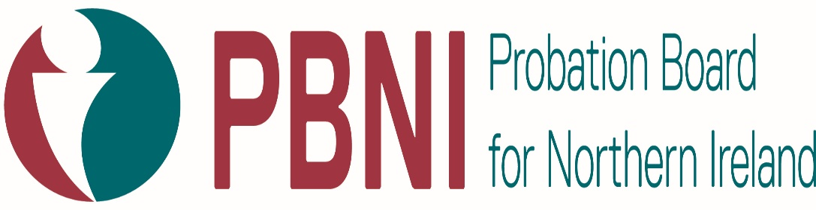

INTRODUCTION

Welcome to the new Disability Action Plan (DAP) for the Probation Board for Northern Ireland. This DAP sets out the actions the Probation Board for Northern Ireland intend to take over the next five years in response to our disability duties under Section 49A of the Disability Discrimination Act 1995 (as amended) over the next five years.

Our Disability duties are to:
- promote Positive Attitudes Towards People with Disabilities.
- encourage Participate by Disabled People in Public Life.

PBNI’S WORK
The Probation Board for Northern Ireland (PBNI) has a presence across all communities and is a central part of the criminal justice system. It works to address the causes of offending to help prevent people coming back into the system and protect the public. The services we provide enable individuals to change their behaviour which in turn reduces the likelihood of reoffending. This reduces the numbers of victims, and makes communities safer.
Our aim is to change people’s lives for safer communities.

Our staff work in a range of occupations in PBNI. The majority of our staff deliver front line services dealing directly with our 4000 Service Users. This includes managing people on probation (those serving a community sentence or who have been released from prison subject to licence) and preparing pre-sentence reports for judges and magistrates in the courts to enable them to choose the most appropriate sentence. Staff also work in prisons preparing people for release into the community and we provide an information service for victims of crime.

PBNI’s Board is tasked is tasked with setting the strategic vision and monitoring the service’s performance against objectives. As a Board they take an active role in the promotion of welcoming, diverse and inclusive organisation.

We have developed this DAP to progress our two disability duties to promote positive attitudes and encourage full participation of disabled people in public life.

Actions to address inequalities experienced by disabled people are also included in our five year Equality Action Plan (EAP).

It is important to note that it is recognised that PBNI use the social model definition for disability which recognises people as disabled by barriers in society and environment and not by any impairment or difference.

CONSULTATION
We welcome feedback on the draft DAP we are presenting during a 14 week consultation which will run from Friday, 20 December 2024 to Friday, 21 March 2025.
The actions and priorities in this DAP have so far been informed by research in relation to equality issues we experience and know about, and among other organisations; a review of information provided by the Equality Commission for Northern Ireland; and consultation with our staff and our service users; and with bodies representing disability issues.

During the lifetime of this DAP, we will continue to gather information about our service users in relation to the Section 75 groups and update our staff equality information in the lifetime of this plan. We also intend during the lifetime of this plan to carry out an audit inequality to use during reviews our DAP and Equality and Good Relations Action Plan (EAP) in the future.

When the consultation period ends, we will update this DAP so that it can be put into effect as quickly as possible.
Our intention is to have actions that will make a real and meaningful difference to the lives of people who work for us and our service users, by addressing the inequalities they experience or to better promote equality of opportunity.

WHAT IS IN OUR DAP?
The following tables outline our actions for the next five years. The Plan includes actions aimed at:

- promote Positive Attitudes Towards People with Disabilities.
- encourage Participate by Disabled People in Public Life.

HOW WILL WE MEASURE PROGRESS AND SUCCESS?
This five year DAP is designed to be flexible and responsive to changing circumstances and needs and will evolve over its lifespan.
We will report annually on our progress against the DAP via our S75 Annual Progress Report to the Equality Commission for Northern Ireland (ECNI), which is submitted at the end of August each year and available on our website.

SECTION 1: ACTIONS TO PROMOTE POSITIVE ATTITUDES TOWARDS PEOPLE WITH DISABILITIES

As a service provider and employer we have a role to play in shaping and modelling positive attitudes towards disabled people. Section 1 of this Disability Action Plan focuses on promoting positive attitudes through an inclusive approach to the use of images and language, providing better training, guidance and support for our staff and ensuring our Disability Action Plan is easy to access.

What we aim to achieve | What we will do (Actions) | By when | How we measure success
Increase visibility of disabled people – from among our staff and service users. | - We will continue to promote disability equality and the social model of disability through an inclusive approach to the use of images, which reinforce a positive towards disabled people and disabled staff members. | Throughout the lifetime of the plan. | - Increased visibility of disabled people and disabled staff, including those with hidden disability in PBNI publications, use of social media and online presence.
 | - We will mark and celebrate disability by promoting and publicising disability related days and events. | Throughout the lifetime of the plan. | - Produce calendar of events organised and publicised annually.  - Increased staff awareness of disability equality.
Make our Disability Action Plan is accessible and easy to understand. | - We will consult widely to enhance the profile and accessibility of the Disability Action Plan to ensure that the legislation and disabled people’s issues are easier to understand. | March 2025 | - Increased awareness of the accessible Disability Action Plan internally and externally.  - Disability Action Plan available on PBNI website including Easy Read and Signed versions  - Proactively disseminate the Disability Action Plan to key stakeholders.
All PBNI staff should be trained on disability equality and disability duties. | - We will review our staff training programmes and ensure that training is informative. During the lifetime of this policy we will work to achieve training that reflects lived experience and includes information on disability equality and the disability duties. | March 2026 and review  annually | - Evaluation of training completed.  - Feedback on training gathered from staff to inform the evaluation.  - Increased awareness of disability duties.  - Co-production of training resources on disability equality and disability duties.

SECTION 2: ACTIONS TO ENCOURAGE PARTICIPATE BY DISABLED PEOPLE IN PUBLIC LIFE

Actions in this section focus on increasing disabled people’s participation in decisions about policies and service development.

It is important to note that PBNI do not have direct control over public life positions however we do have disabled people in our Service User groups and among workforce in general, so we have also included actions to ensure these opportunities are accessible and promoted.

What we aim to achieve | What we will do (Actions) | By when | How we measure success
Enable people with a disability to get involved, be heard and inform decisions in PBNI. | - We will share opportunities for involvement to ensure the voice of disabled people is heard in developments and changes to our services at an early stage. | Throughout the lifetime of the plan | - Development of a specific consultee database of organisations representing people with disabilities and determine the best way for involvement  - Consultee database reviewed and updated annually.  - Promotion of a staff disability forum; and involvement opportunities for service users with disabilities in Service User fora.
 | - We will work in partnership with relevant key organisations and individuals to identify disability relevant services. | March 2026 | - Development and publicise a range of disability relevant services for our staff and service users.
Consultation methods must be accessible to disabled people | - We will ensure that all consultations are inclusive and use appropriate methods to ensure participation of a wide range of disabled people. | April 2025 and throughout the lifetime of the plan | - Checklist developed that includes standards for the accessibility of public meeting areas, the provision of information in accessible formats.
Enable staff to understand how to involve disabled people in decisions they make about services. | - We will produce guidance for staff on how to effectively engage with disabled people in decision making processes. | April 2026 | - Improved participation of disabled people in consultations about the services we provide.
Policies need to be kept up to date and relevant, to support disabled staff to remain in the workplace. | - We will promote the best use of our Disability (Workplace Adjustment) Passport through team meetings, online training and face to face training. | March 2025 | - Staff take up of the Disability (Workplace Adjustment) Passport.  - Increased understanding of Disability and Reasonable Adjustments in PBNI.
 | - We will develop a Disability guidance to support our Disability Passport. | December 2025 | - Updated Disability Guidance in place.
Promote PBNI’s job opportunities for disabled people . | - We will work ensure our recruitment marketing information showcases our Guaranteed Interview Scheme and our Disability Passport.  - Explore possibility of employment placement schemes for disabled people. | March 2026 | - Opportunities and availability of our employability schemes and placement schemes scoped.  - Established links with bodies who provide placement opportunities.
There is a need to improve visibility and awareness of jobs for anyone  who is disabled. | - We will work towards a Disability Positive Accreditation. | March 2029 | - Disability Positive Accreditation achieved.  - Increased awareness among disabled people of PBNI jobs available.

CONTACT DETAILS
For more details of our achievements in meeting our dual disability duties, please refer to our Annual Progress Report which is available online or by contacting:

Paula Smyth,
People Manager
Equality.screening@probation-ni.gov.uk

