DRAFT
PROTOCOL

BETWEEN

CRIMINAL JUSTICE INSPECTION NORTHERN IRELAND (CJI)

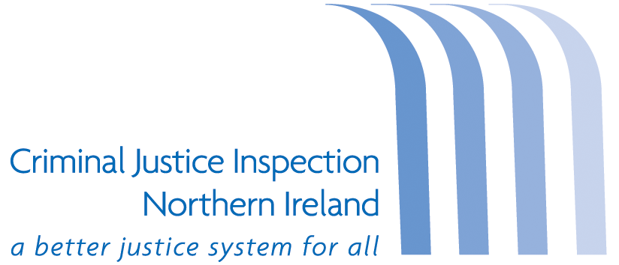

and the

PROBATION BOARD FOR NORTHERN IRELAND
(PBNI)

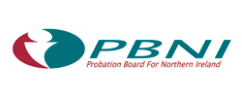

July 2023
Introduction
The purpose of this protocol is to agree working arrangements between Criminal Justice Inspection Northern Ireland (CJI) and the Probation Board for Northern Ireland (PBNI/the Board) that support effective joint working on the conduct of inspections and delivery of agreed recommendations.

Aims and Objectives of the Protocol
- To describe the agreed working arrangements between CJI and the PBNI;
- To strengthen partnership working;
- To ensure there are effective lines of communication so that each organisation can fulfil their roles and responsibilities;
- To provide clarity of roles and responsibilities; and
- To facilitate the legitimate and secure sharing of information.

Criminal Justice Inspection
The Office of the Chief Inspector of Criminal Justice in Northern Ireland was established as an executive Non-Departmental Public Body (NDPB) under section 45 of the Justice (Northern Ireland) Act 2002. The remit of CJI is set out in section 46 of the Act. CJI’s mission is to work closely with the inspected organisations in a professional and mature way by producing relevant, respected inspection reports that add value to the criminal justice system and enhance the public’s experience of contact with every part of the criminal justice system.

The objectives of CJI are to promote efficiency and effectiveness through assessment and inspection; to provide an independent and impartial assessment to Ministers, Permanent Secretaries and the wider community on the working of the criminal justice system; to provide independent scrutiny of the conditions for, and treatment of users of, the justice system; and to work in partnership to deliver high quality independent, impartial inspection reports.

CJI inspects for improvement in the pursuit of excellence. Inspection processes examine organisations for strengths and areas for improvement with a focus on strategic and outcome focused recommendations for performance improvements. Action plans, prepared by inspected organisations, provide the detail on how recommendations will be delivered with progress assessed though follow-up reviews.

Probation Board for Northern Ireland
The PBNI is a NDPB sponsored by the Department of Justice (DoJ); its statutory responsibilities are set out in the Probation Board (NI) Order 1982. The mandatory functions of the Board are to:
- secure the maintenance of an adequate and efficient probation service;
- make arrangements for persons to perform work under Community Service Orders;
- provide such Probation Officers and other staff as the DoJ considers necessary to perform social welfare duties in prisons and Hydebank Wood Secure College; and
- undertake such other duties as may be prescribed.

The discretionary functions of the Board which it may enter into with the agreement of the DoJ are to:
- provide and maintain probation hostels and other establishments for use in connection with the supervision and assistance of offenders;
- provide and maintain bail hostels;
- make and give effect to schemes for the supervision and assistance of offenders and the prevention of crime; and
- make arrangements with voluntary organisations or any other persons (including Government Departments and public bodies) to provide and maintain such hostels and other establishments as mentioned above; and give effect to schemes for the supervision and assistance of offenders and the prevention of crime.

PBNI’s strategic priority and outcomes subject to Ministerial approval of their draft Corporate Plan 2023-2023 are:

- Our people: we will develop, support, and empower our staff to maintain effective service delivery;

- Our services: we will deliver an effective, statutory probation service to reduce reoffending and protect the public;

- Our funding: we will prioritise our budget and estate to maximise service delivery; and

- Our partnerships: we will develop our current partnerships and create new partnerships to help make communities safer.

The delivery of these priorities include the following key functions and services:

- Supervising people in probation;

- Preparing pre-sentence reports;

- Public protection through the Public Protection Arrangements NI;

- Programmes and interventions;

- Working in prisons;

- Community service; and

- Providing an information service to victims.

Inspection methodology
Design and Planning
The Chief Inspector conducts meetings with the agencies and stakeholder organisations to inform the priorities for inspection. A draft inspection programme is discussed with agencies and stakeholders before submission to the Minister (or in their absence the DoJ Permanent Secretary) and publication in the CJI annual Business Plan.

Pre-inspection research is undertaken by Inspectors to better inform the Terms of Reference including the scope of the inspection. This may also include a range of meetings with key staff in relevant criminal justice organisations. A draft of the Terms of Reference is shared with the PBNI for comment.

The Chief Inspector will write formally to the Chief Executive of the PBNI to inform them of the intention to conduct an inspection and requesting advance material. A copy of the Terms of Reference for the inspection is enclosed at this stage.

Delivery of Inspection
A self assessment of the current situation, or progress made against recommendations in follow-up reviews, may be requested from the PBNI. Support from CJI will be provided where requested and feasible.

A fieldwork plan, to include the timing of meetings with the PBNI will be prepared by the Lead Inspector in conjunction with liaison and other nominated contact points in criminal justice organisations. The nominated contact point in the PBNI is the Director of Operations (Community and Courts).

An end-of-fieldwork review meeting is held with head(s) / functional lead(s) of inspected organisation(s) to discuss emerging findings.

Analysis and drafting of reports
The analysis and drafting of the report is undertaken by the Lead Inspector in compliance with the CJI internal quality assurance management system. This includes an internal peer review process together with ongoing discussions with the PBNI.

The final draft report is approved by the Chief Inspector for release to the PBNI for a factual accuracy check and an action plan to address the recommendations. The factual accuracy check is for matters of factual accuracy only and should not suggest the rewording of Inspector’s analysis or point out typographical errors.

The response to the factual accuracy check and the action plan is expected within four weeks and the PBNI should aim to meet that timescale. Where the inspection is assessed to be complex in nature, the Chief Inspector may agree a longer timeframe for the preparation of an action plan.

Pre-Publication
The Chief Executive of the PBNI will receive a copy of the final report under embargo in advance of the publication date.

CJI will share its intended press release with the PBNI and where appropriate the relevant Department of Justice sponsor team and expects the PBNI and DoJ to reciprocate.

Post-Publication
The Chief Executive of the PBNI will work towards the implementation of all accepted recommendations.

The Chief Inspector will seek an explanation from the Chief Executive of the PBNI on any recommendation not accepted.

The Chief Executive of the PBNI will provide an update on performance against each of the accepted recommendations at an agreed interval(s) between publication and commencement of a follow-up review.

The PBNI has internal performance reporting mechanisms to report on progress against accepted inspection recommendations on a quarterly basis (to the PBNI Audit Committee) and can provide a six monthly or annual report of progress to CJI.

Information and data sharing
It will be the responsibility of the signatories to this agreement, when personal data is being shared, to ensure that there is full compliance with all relevant legislation including the Data Protection Act 2018, General Data Protection Regulation and all internal NICS and DoJ Data Sharing Protocols. Information must only be transmitted or shared in line with the appropriate policy applicably for the protective marking on the document. The relevant information will be retained by the party to whom it is disclosed until it is no longer required for the purpose for which it was shared and must be kept no longer than necessary.

Information discovered to be inaccurate or inadequate for the specified purpose will be brought to the notice of the originator of the data. The originator will be responsible for correcting the information. The data must only be used for the purpose of factual accuracy. It cannot be used or disclosed for any other reason.

Information Assurance
CJI and the PBNI endorse the Information Assurance requirement to promote an environment in which the confidentiality, integrity and availability of systems and processes are protected. Each of the parties to this agreement is responsible for ensuring that they have appropriate security arrangements in place. Information to be shared must be protectively marked under the His Majesty’s Government Protective Marking Scheme. CJI and the PBNI will comply with updated guidance on information sharing.

Escalation and resolution
Any disagreements or disputes arising out of these protocol provisions should be escalated to the relevant PBNI Director and the Deputy Chief Inspector CJI for resolution. Where agreement is not reached in the above instances, issues may be escalated to be resolved by the Chief Inspector of CJI and the Chief Executive of the PBNI.

Review arrangements
This protocol will be reviewed as necessary but at least every three years. The Chief Inspector of CJI and the Chief Executive of PBNI are the designated reviewing officers but may delegate authority to do so to appropriate staff as agreed. Such reviews will be ratified by the Chief Inspector and the Chief Executive in the course of routine liaison.

Review of the Protocol
This Protocol will be reviewed in 2026.

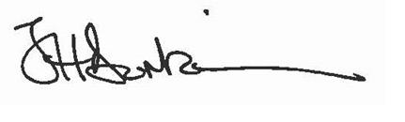Date: 31 July 2023
Signed:

Jacqui Durkin
Chief Inspector
Criminal Justice Inspection
Block 1, Knockview Buildings,
Stormont Estate,
Belfast
BT4 3SJ

Signed: 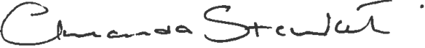 Date: 31 July 2023

Amanda Stewart OBE
Chief Executive
PBNI
80-90 North Street
Belfast
BT1 1LB

